Freudian Psychological Society
Educational Visits (2022-2023):
- Date: 10th February 2023
Resource Person: Mr Atul Madaan, Clinical Psychologist and Chief Advisor, Care for Autism Foundation
Activity: Educational Visit to Care for Autism Foundation, Jalandhar
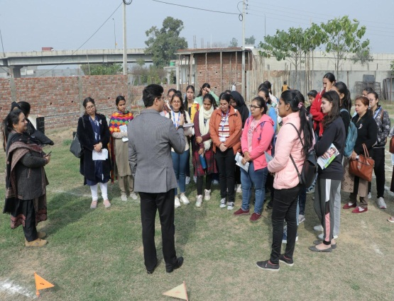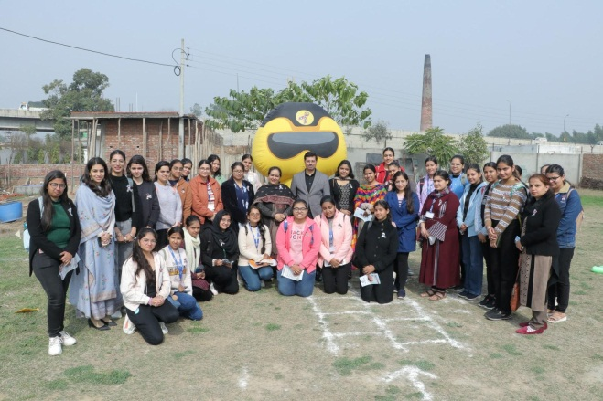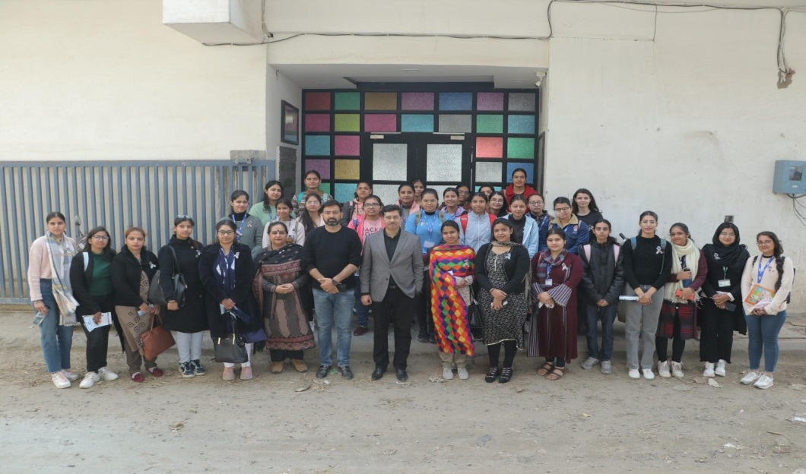

- Date: 18th March 2023
Activity: Visit to Golden Temple, Jalianwala Bagh, Gobindgarh Fort, Amritsar
